Laravel Tutorial

Laravel tutorial provides basic and advanced concepts. Our Laravel tutorial is designed for beginners and professionals.

**Laravel** is an open-source PHP framework. It also offers the rich set of functionalities that incorporates the basic features of PHP frameworks such as Codelgniter, Yii, and other programming languages like Ruby on Rails.

Our Laravel tutorial includes all the topics such as introduction, history of Laravel, installation, Laravel routes, Laravel controllers, Laravel views, etc.

## What is Laravel?

Laravel is a PHP framework that uses the MVC architecture. **Where-**

* **Framework:** It is the collection of methods, classes, or files that the programmer uses, and they can also extend its functionality by using their code.
* **Architecture:** It is the specific design pattern that the framework follows. Laravel is following the MVC architecture.

## Advantages of Laravel

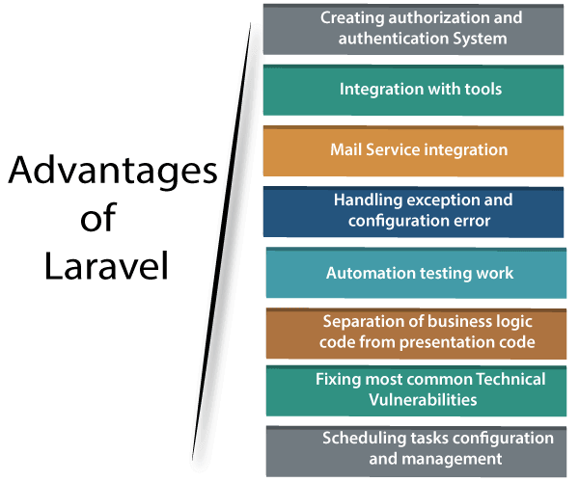

## Following are the features of Laravel:

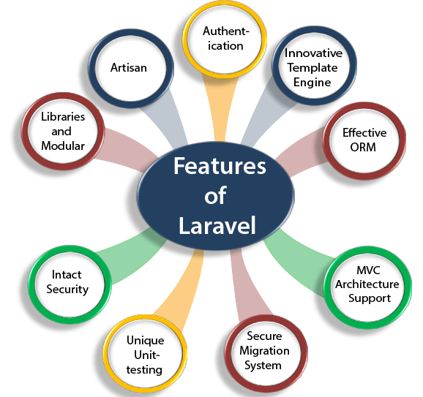

### Artisan

Laravel framework provides a built-in tool for a command-line known as **Artisan** that performs the repetitive programming tasks that do not allow the php developers to perform manually. These artisans can also be used to create the skeleton code, database structure, and their migration, so it makes it easy to manage the database of the system. It also generates the MVC files through the command line. Artisan also allows the developers to create their own commands.

**Following are some important commands used in Composer:**

* **install**  
  The install command is used to install all the libraries or packages from the **composer.json** file. This command is used to download all the PHP dependency repositories from the **composer.json** file.
* **require**  
  The **require** command is used to add the libraries or packages as a parameter to the file **composer.json**, and then install it. Suppose I want to add the **facebook php SDK** in composer.json file.
* **update**  
  The update command is used to update all the libraries or packages from the **composer.json** file based on the versions mentioned in the composer.json file. We can say that the **update** command updates the dependencies to the latest versions.
* **remove**  
  The remove command is used to uninstall the library or package and remove it from the **composer.json** file.

### Steps to download the Composer:

**Following are the steps to download the Composer:**

* Click on the link given below to download the Composer: <https://getcomposer.org/download/>.
* To download the Composer for Windows, click on the link **Composer-Setup.exe**.

# Creating First Laravel Project

In this topic, we are going to create the first laravel project. To create the **Laravel** project, we will be using **Git** and **Composer**.

 we use the command **composer create-project laravel/laravel firstproject**.

**laravel/laravel:** proj  
**firstproject:** It is a project name.